**CS 121 Homework Assignment Three – (With corrections)**

The following problems require the file dictionary_four_letter_words.txt.

1. Spell check. Given a string of four consecutive characters input by the user determine if it is a word. Your program should allow the user to input as many words as they want – one at a time.
2. Using the dictionary of four letter words print out (to the screen) all words that are palindromes. (Words that are the same forward and reverse like peep, and noon.)
3. Given the word find puzzle below locate and print out all four letter words. The words can appear in their normal form or reversed. There are no vertical or diagonal words – yet. Process one line at a time. For easier processing make a simple txt file with the following 10 lines. **You may use lowercase if you prefer.**

PXABACKEGS  
ESORELATED  
MOONKCENT  
ZRLLABLEAD  
MSRKRADMCF  
FLOORTJUIKV  
STRXMICEDC  
QUTAMKTSUD  
RXQUITMMUY  
DATASETLAS

The following problem requires the Weather Station data **file AL_Weather_Station.txt** available from the syllabus. Here is a portion of the raw data file:

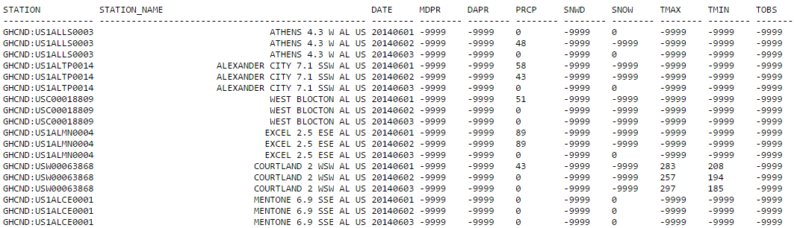

4. Using the Weather Station data file:

a. Produce a new data file that eliminates all entries with missing or bad data for maximum temperature **(TMAX)** or minimum temperature **(TMIN).** Missing or bad data is denoted by the flag -9999. This new file will be used in problems b, c and d below. NOTE: The temperatures are given in tenths of a degree Celsius. e.g 283 is 28.3 degrees C.

b. Using the filtered data file from part a, create another file with only the following information:

STATION NAME DATE TMAX TMIN

The date should be in MM DD YYYY format and the temperatures should be converted from Celsius to Fahrenheit. Here is a sample of the output. You may left justify station name if you like.

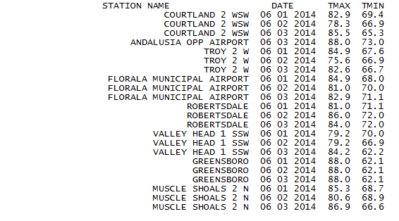

c. Determine the highest and lowest temperatures in the state for June 1, 2 and 3. Print out (to the screen) the station names with highest and lowest temperatures along with the high and low. (Multiple stations may record the same values for high and low.)

d. Create a new file for weather stations in North Alabama. The station names are:

ATHENS  
DECATURCULLMAN  
OWENS CROSS ROADS  
MUSCLE SHOALS  
  
SCOTTSBORO  
HUNTSVILLE INTERNATIONAL AIRPORT JONES FIELD